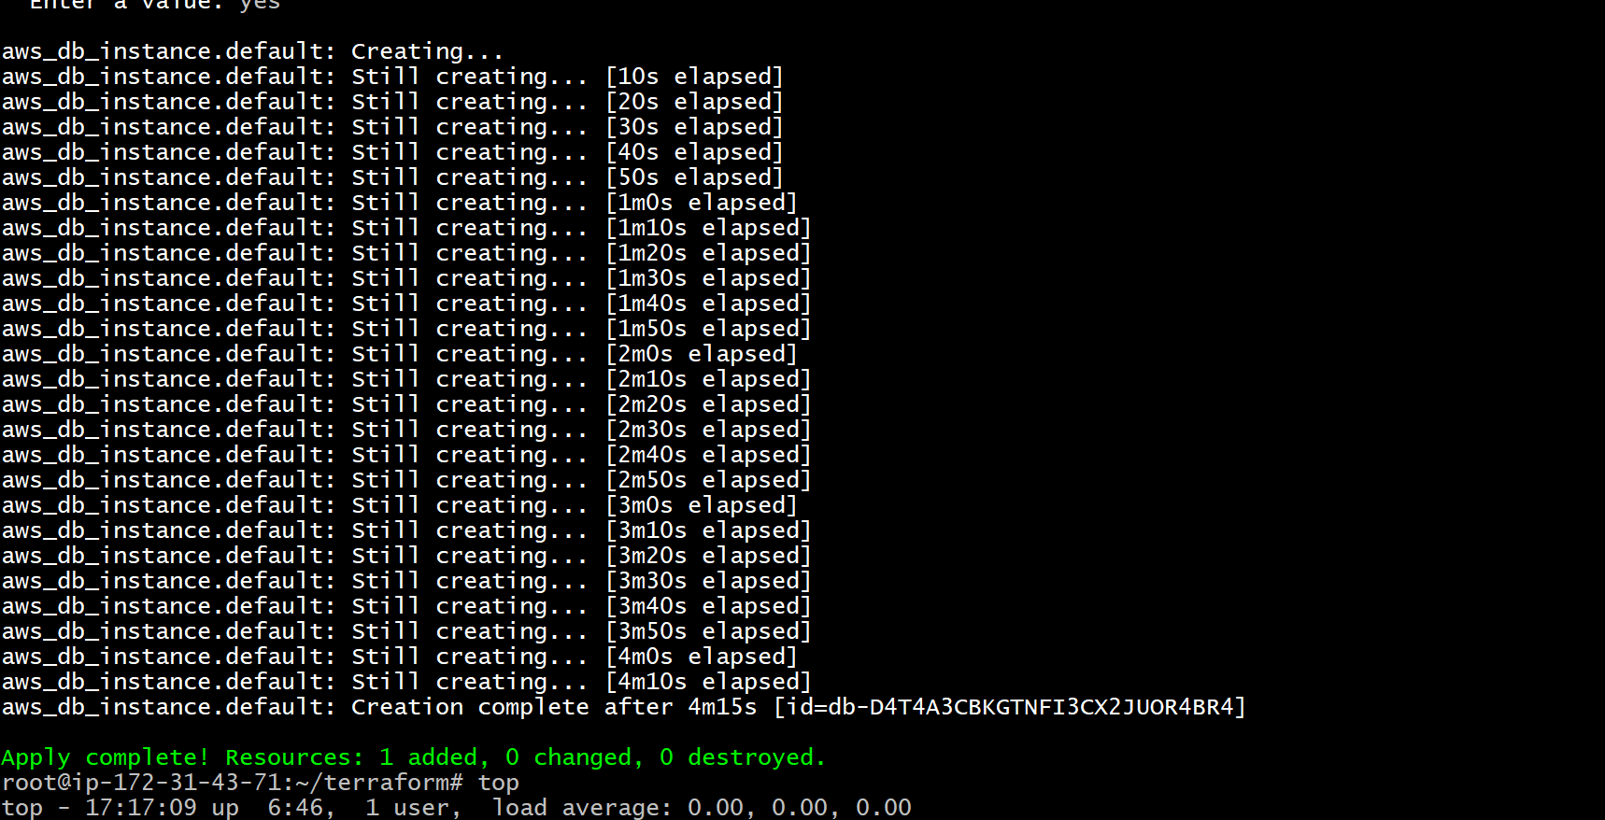

VPC

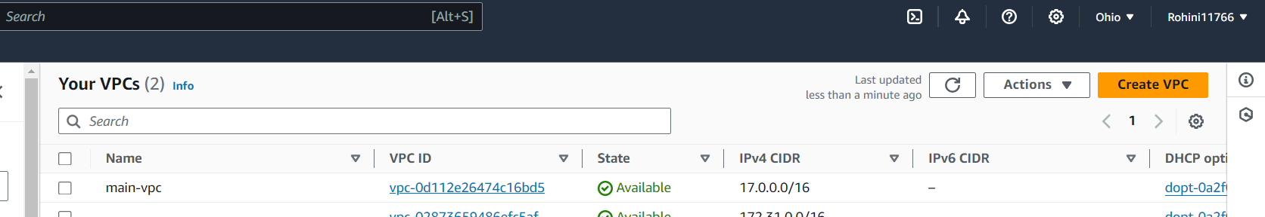

Subnets

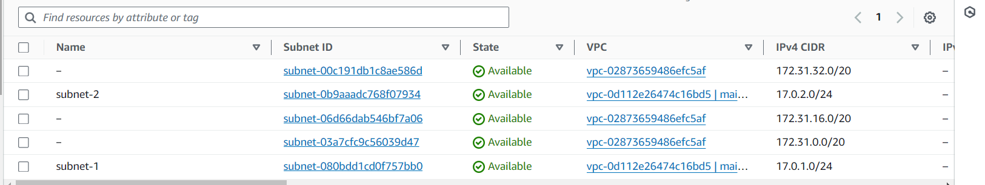

Route tables

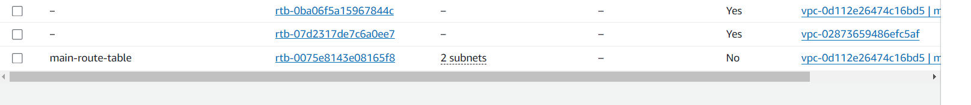

Igw



LOAD BALANCER

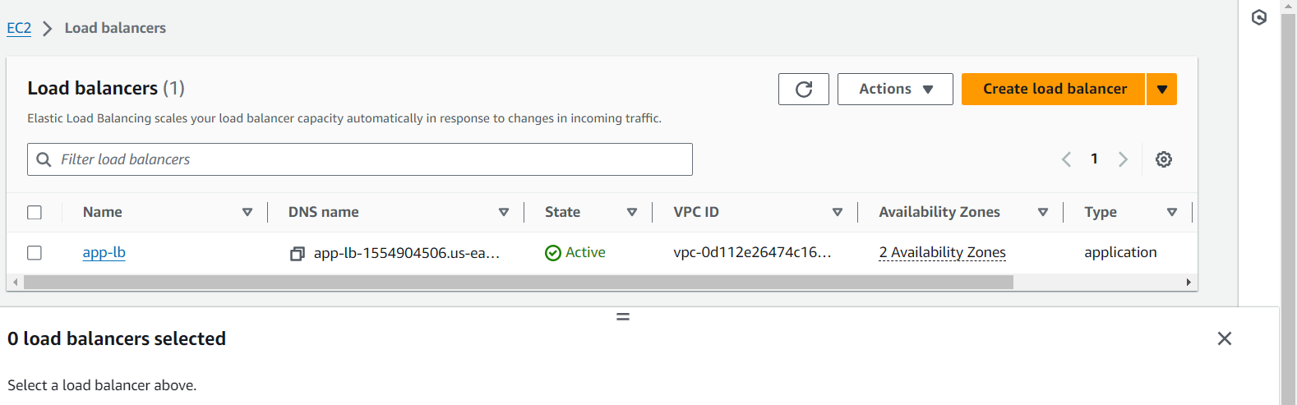

Target Group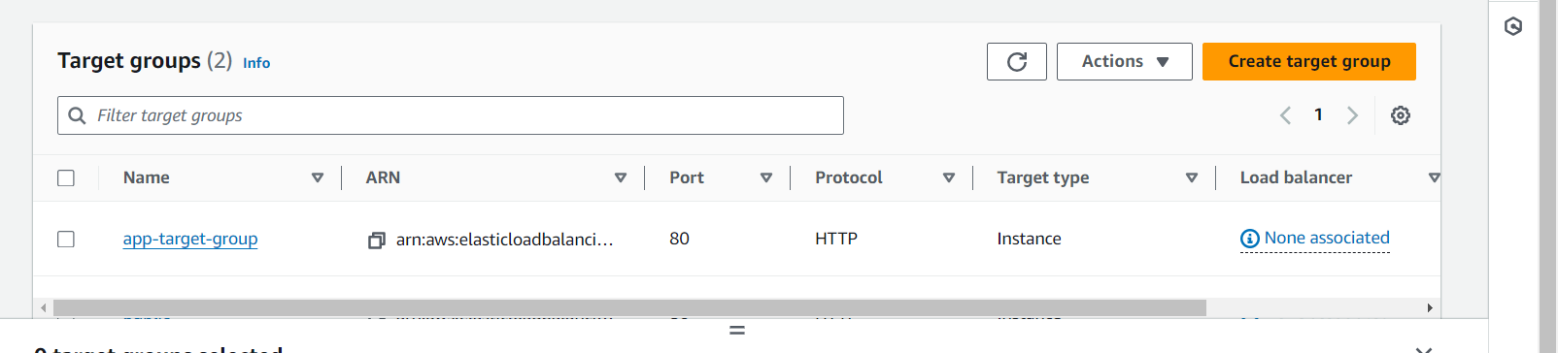

Auto scaling

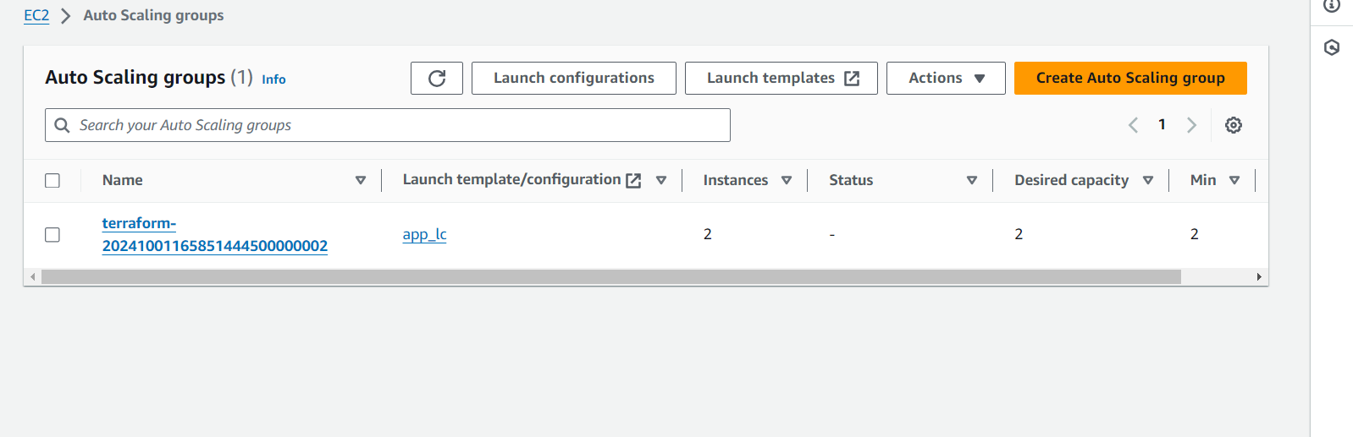

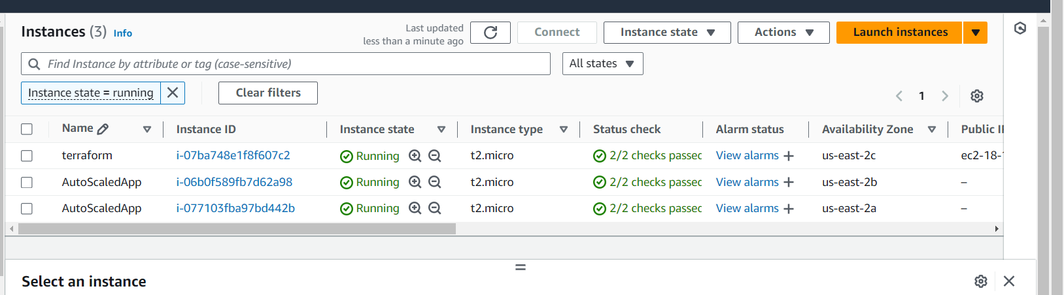

RDS

